**MYSQL Project** :

**1.How many orders has each customer placed?**

select

c.Name, count(o.orderID) as total_order

from customers c

join orders o on c.customerID = o.orderID

group by c.Name;

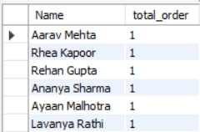

**2.Which customers have placed more than 1 order?**

select

c.Name, count(o.orderID) from customers c

join orders o on c.customerID = o.customerID

group by c.Name

having count(o.orderID) > 1;

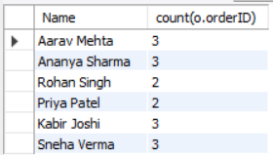

**3.What is the latest order date for each customer?**

select

c.Name,max(o.orderDate) as lateset_date

from customers c

join orders o on c.customerID = o.customerID

group by c.Name;

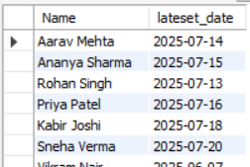

**4.** **Which customers placed orders in June 2025?**

select

c.Name, o.OrderDate

from customers c

join orders o on c.customerID = o.customerID

where o.orderDate between '2025-06-01' AND '2025-06-30';

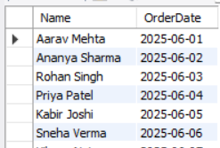

**5.Has customer 'Priya Patel' ever placed an order?**

select

count(*) as priya_order

from orders o

where o.customerID = (

select customerID from customers where Name = 'priya patel');

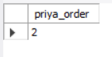

**6.List all orders along with the customer name.**

select

c.Name,o.orderID,o.orderDate

from orders o

join customers c on c.customerID = o.customerID;

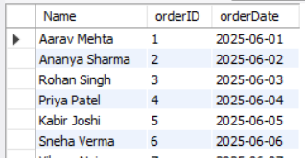

**7.Which customer placed order with OrderID = 10?**

select

c.Name, o.orderDate

from customers c

join orders o on c.customerID = o.customerID

where o.OrderID = 10;

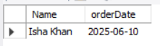

**8.List names of customers who placed order IDs 1, 2, or 3.**

select

c.Name, o.OrderID

from customers c

join orders o on c.customerID = o.customerID

where o.OrderID in (1,2,3);

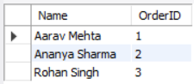

**9.Total quantity of products ordered by each customer.**

select

c.Name,sum(od.Quantity) as total_qt

from Customers c

join Orders o on c.customerID = o.customerID

join orderDetails od on o.orderID = od.orderID

group by c.Name;

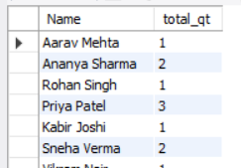

**10.How many different products were ordered in each order?**

select

o.orderID,count(distinct od.productID) as productCount

from orders o

join orderDetails od on o.orderID = od.orderID

group by o.orderID;

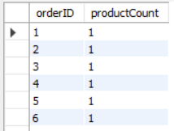

**11.List product name along with its category name**.

select

p.Name,c.categoryName

from products p

join categories c on p.categoryID = c.categoryID;

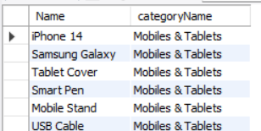

**12.How many products are there in each category?**

select

c.categoryName, count(p.productID)

from products p

join categories c on p.categoryID = c.categoryID

group by c.categoryName;

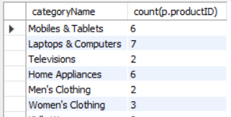

**13.Which are the top 5 most expensive products?**

select

Name,Price

from products

order by price desc limit 5;

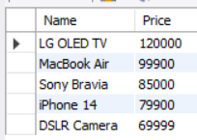

**14.List products with stock less than 50 and their category name.**

select

p.Name,p.stockQuantity,c.categoryName

from products p

join categories c on c.categoryID = p.productID

where p.stockQuantity < 50;

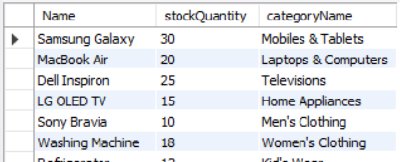

**15.Which product has the highest discount amount?**

select

p.Name , d.discountAmount

from products p

join discounts d on d.productID = p.productID

order by d.discountAmount desc limit 1;



**16.Total discount amount provided per category.**

select

c.categoryName,sum(d.discountAmount) as totalDiscount

from categories c

join products p on p.categoryID = c.categoryID

join discounts d on d.productID = p.productID

group by c.categoryName;

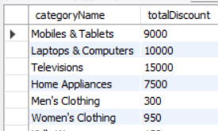

**17.List product names with their final price after discount.**

select

p.Name, (p.price - d.discountAmount) as finalPrice

from products p

join discounts d on p.productID = d.productID;

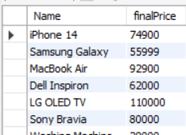

**18.Which products are priced above the average product price?**

select

Name,price as abovePrice

from products where price > (select avg(price) from products);

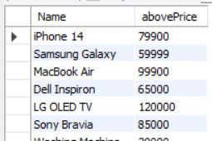

**19.List products that have a discount less than 500.**

select

p.Name,d.discountAmount as disamt

from products p

join discounts d on d.productID = p.productID

where d.discountAmount < 500;

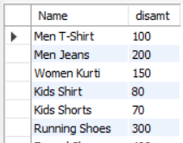

**20.List products that do not have any discount.**

select

Name from products

where productID not in (select productID from discounts);

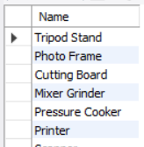

**21. List all customers who have given a review with a rating of 5.**

select

c.Name,r.rating

from customers c

join reviews r on r.customerID = c.customerID

where r.rating = 5;

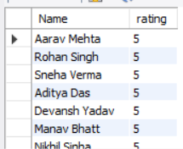

**22.Find all products that have a discount of more than ₹2000 and are currently in stock.**

select

p.Name,d.discountamount,p.StockQuantity

from products p

join discounts d on p.productID = d.productID

where d.discountAmount > 2000 & p.StockQuantity > 0;

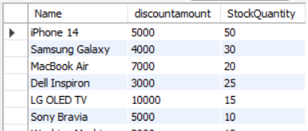

**23. Find the most expensive product in each category.**

select

categoryID,Name,price

from products p1

where price = (select max(price) from products p2 where p1.categoryID = p2.categoryID);

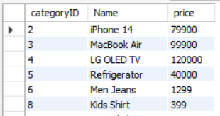

**24. Show the average rating for each product (only if it has been reviewed).**

select

p.Name,avg(r.rating)

from products p

join reviews r on r.productId = p.productID

group by p.Name;

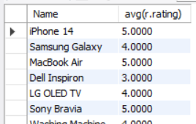

**25. Find names of all customers who ordered a product that costs more than ₹50,000.**

select

distinct c.Name

from customers c

join orders o on c.customerID = o.customerID

join orderDetails od on od.orderID = od.orderID

join products p on p.productID = od.productID

where p.price > 50000;

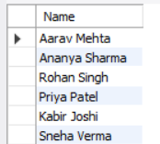

**26. Show the number of orders placed for each product.**

select

p.Name,count(od.orderID) as TotalOrders

from products p

join orderDetails od on od.productID = p.productID

group by p.Name;

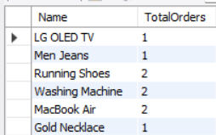

**27. Find all orders that took more than 5 days to deliver.**

select

o.orderID,s.shipDate,s.deliveryDate

from orders o

join shipping s on s.orderID = o.orderID

where datediff(s.deliveryDate,s.shipDate) >= 5;

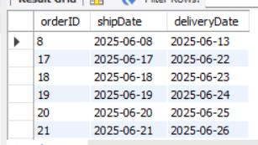

**28.Get the top 5 most ordered products (by quantity).**

select

p.Name, sum(od.quantity) as totalQty

from products p

join orderDetails od on od.productID = p.productID

group by p.Name

order by totalQty desc limit 5;

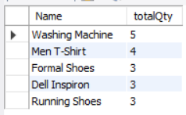

**29.Show product names and prices that have never been ordered.**

select

p.Name,p.price

from products p

where p.productID not in (

select distinct productID from orderDetails);

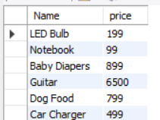

**30. Find the total amount (price × quantity) each customer has spent.**

select

c.Name,sum(p.price * od.quantity) as totalAmt

from customers c

join orders o on o.customerID = c.customerID

join orderDetails od on od.orderID = o.orderID

join products p on p.productID = od.productID

group by c.Name;

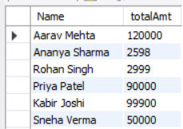

**31. Which products have been reviewed by more than 3 customers?**

select

p.Name,count(r.reviewID) as reviewed

from products p

join reviews r on r.productID = p.productID

group by p.Name

having reviewed > 3;

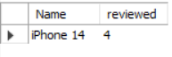

**32. Find all orders placed in the month of June 2025.**

SELECT * FROM Orders

WHERE OrderDate LIKE '2025-06%';

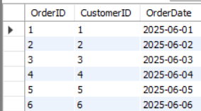

**33. List customers who have reviewed products they did not order.**

select

distinct c.Name

from Customers c

join Reviews r on c.CustomerID = r.CustomerID

where not exists (

select 1 from Orders o

join OrderDetails od on od.OrderID = o.OrderID

where o.CustomerID = r.CustomerID and od.ProductID = r.ProductID

);

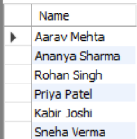

**34. Find the category that has the most products listed.**

select

c.CategoryName, count(p.productID) as totalProducts

from Categories c

join products p on p.categoryID = c.categoryID

group by c.CategoryName

order by totalProducts desc limit 1;



**35. Show top 5 customers who spent the most in total.**

select

c.Name, sum(p.price * od.quantity) as totalSpent

from customers c

join orders o on o.customerID = c.customerID

join orderDetails od on od.orderID = o.orderID

join products p on p.productID = od.productID

group by c.Name

order by totalSpent desc limit 5;

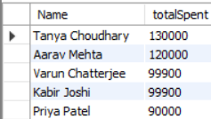

**36. Which products have a discount more than 25% of their price?**

select

p.Name, p.price, d.discountAmount

from products p

join discounts d on d.productID = p.productID

where (p.price * 25 / 100) < d.discountAmount;

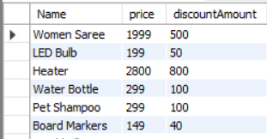

**37. Display average shipping time (in days) for all orders.**

select

avg(datediff(deliveryDate,shipDate)) as AvgShippingDate

from shipping;



**38. Show orders that include at least 3 different products.**

select

o.orderID,count(distinct p.productID) as countProduct

from orders o

join orderDetails od on od.orderID = o.orderID

join products p on p.productID = od.productID

group by o.orderID

having countProduct >= 3;



**39. Find forth highest product price.**

select * from products order by price desc limit 1 offset 3 ;



**40. Find customers who haven’t placed any order.**

select

c.Name from customers c

where c.customerID not in (select customerID from orders);

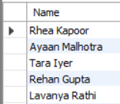

**41.Customers who ordered more than 2 products in a single order.**

select

o.orderID,c.Name,count(od.productID) as productCount

from orders o

join customers c on c.customerID = o.customerID

join orderDetails od on od.orderID = o.orderID

group by o.orderID,c.Name

having productCount > 2;



**42. Products that have never been ordered**

select

p.productID,p.Name from products p

where p.productID not in (select productID from orderDetails);

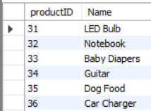

**43. Show customers who used the most discounted product in their order**

select

c.Name,p.Name as productName, d.discountAmount

from orders o

join customers c on c.customerID = o.customerID

join orderDetails od on o.orderID = od.orderID

join products p on od.productID = p.productID

join discounts d on d.productID = p.productID

where d.discountAmount = (select max(discountAmount) from discounts);



**44. Which products were ordered the most (by total quantity)?**

select

p.Name,sum(od.Quantity) as totalQty

from products p

join orderDetails od on p.productID = od.productID

group by p.Name

order by totalQty desc limit 1;



**45. Find which category has the highest average price of products.**

select

c.CategoryName, avg(p.price) as avgPrice

from products p

join categories c on c.CategoryID = p.CategoryID

group by c.CategoryName

order by avgPrice desc limit 1;



**46.What is the total number of orders placed?**

select count(*) as total_order from orders;



**47.Top 5 customers with the highest number of orders**

SELECT C.Name, COUNT(O.OrderID) AS OrderCount

FROM Customers C

JOIN Orders O ON C.CustomerID = O.CustomerID

GROUP BY C.CustomerID

ORDER BY OrderCount DESC

LIMIT 5;

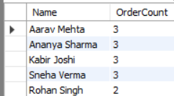

**48. Show orders that contain products from more than one category.**

SELECT od.OrderID

FROM OrderDetails od

JOIN Products p ON od.ProductID = p.ProductID

GROUP BY od.OrderID

HAVING COUNT(DISTINCT p.CategoryID) > 1;



**49.Find total orders per day for the last 10 days in the dataset.**

select

orderDate,count(orderID) as orderDate

from orders

group by orderDate

order by orderDate desc limit 10;

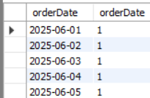

**50.Show all categories that have at least 1 product with price over ₹50,000**

select

distinct c.CategoryName

from categories c

join products p on p.categoryID = c.categoryID

where p.price > 50000;

